EVENT DESCRIPTION SHEET
(To be filled in and uploaded as deliverable in the Portal Grant Management System, at the due date foreseen in the system.
Please provide one sheet per event (one event = one workpackage = one lump sum).)
PROJECT
Participant: | LOKALNA AKCIJSKA GRUPA PRIGORJE-ZAGORJE (LAG PRIZAG)
PIC number: | 940443907,
Project name and acronym: | EU cultural landscape – EU landscape

EVENT DESCRIPTION
Event number: | 1
Event name: | International conference of EU landscape project
Type: | Conference
In situ/online: | in-situ
Location: | Croatia, Novi Marof & Breznički Hum
Date(s): | 07.11 – 09.11. 2025
Website(s) (if any): | https://www.lag-prizag.hr/category/eu-krajobraz/
Participants
Female: | 156
Male: | 95
Non-binary: | 0
From country 1 [Slovenia]: | 67
From country 2 [Serbia]: | 43
From country 3 [Bulgaria]: | 4
From country 4 [Hungary]: | 8
From country 5 [Italy]: | 2
From country 6 [Bosnia and Herzegovina]: | 12
From country 7 [Croatia]: | 115
Total number of participants: | 251 | From total number of countries: | 7
Description
Provide a short description of the event and its activities.
The project “EU Landscape” was implemented through a three-day transnational programme involving approximately 251 participants from seven partner countries within the CERV framework. The activities promoted the protection and valorisation of cultural landscapes and strengthened cooperation among rural communities.
The programme included official opening sessions, partner presentations, a documentary film screening, group debates, a guided visit, and a round table with experts and local authorities. Cultural activities and participation in a local fair increased public engagement and visibility.
Key achievements include the production and public presentation of a documentary film on the cultural landscape of the LAG PRIZAG area and the signing of a Cooperation Agreement by all partners, establishing a basis for future joint EU projects.
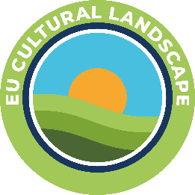
Agenda of the event
DAY 1 (Friday, 07 November 2025)
• Arrival of participants on 07 November 2025 in the late afternoon, to accommodation units according to the schedule
• 19:00 / 20:00 – Dinner for participants at the restaurant
• Welcome speech by the President of the LAG and mutual introduction of participants

DAY 2 (Saturday, 08 November 2025)
Venue: Cultural Center Novi Marof (main hall)
10:00 – 10:30 – Registration of participants
10:30 – 12:00 – Working session
• Opening speeches and introduction to the Project
• Presentation of Project partners
(each partner will have 10 minutes – 6 partners × 10 minutes = 60 minutes)
• Documentary film by the host – LAG PRIZAG
“Landscape Features in the LAG PRIZAG Area”
• Possible discussion
12:00 – 12:15 – Refreshment break
12:15 – 13:30 – Group work – DEBATE
Topic: “EU Cultural Landscape”
Two groups:
- Bosnia and Herzegovina, Serbia, and Croatia
– led by Lidija Zečević
- Hungary, Italy, Bulgaria, and Slovenia
– led by Marina Benjak Bregeš
• Discussion / participant comments
13:30 – 14:30 – Lunch at the restaurant Ključice
14:30 – 15:30 – Visit to one of the local sites featured in the host’s documentary film
• Organized by the Novi Marof Tourist Board
• Group photo session
15:30 – 16:30 – Presentation of group results and viewpoints
Topic: “EU Cultural Landscape”
With participation of experts and public sector representatives:
• Sanja Kopjar, M.Sc. Agr., Director of the Public Institution for the Management of Protected Natural Areas of Varaždin County
(Public Institution “Priroda Varaždinske županije”)
• Siniša Jenkač, Mayor of the City of Novi Marof
• Renata Horvatić, Director of the Tourist Board of Novi Marof
• Signing of the Cooperation Agreement
17:00 – 19:00 – Breznički Hum
• Brass Band Concert by the “St. Martin Brass Band Association”
20:00 – Dinner and return of participants to accommodation units

DAY 3 (Sunday, 09 November 2025)
Venue: Breznički Hum
09:30 – 10:00 – Registration of participants
10:00 – 13:00 – Participation of guests at the Prigorsko-Zagorski Autumn Fair
• Dissemination of Project Results – EU Cultural Landscape
• Discussions about future EU projects focused on rural areas, preservation of life and work in rural regions, and the valorization and protection of cultural landscapes
• Departure of participants

Description of the activities
The Conference activities were implemented in a clear and logical sequence, following the planned programme and enabling active participation of all partners.
The programme began with the presentations of project partners, during which each partner introduced their organization, project role and examples of best local initiatives from their respective regions. This initial segment set the framework for mutual understanding, knowledge exchange and partnership cooperation.
Following the partner presentations, a thematic documentary film prepared by the host organization, LAG PRIZAG, was screened. The film focused on landscape features and cultural characteristics of the LAG PRIZAG area and served as a visual introduction to the main conference topic. A link of documentary film: https://www.youtube.com/watch?v=5k2VCDSO56E
After the film screening, participants took part in structured group work in two debate groups on the topic “EU Cultural Landscape”. The debates were organized in an interactive format, encouraging open dialogue, exchange of opinions and sharing of experiences among all project partners. This was followed by a joint discussion involving all participants, allowing different perspectives to be presented and compared in a plenary setting.
In the continuation of the programme, participants joined a one-hour guided tour focused on the cultural landscape of Novi Marof, the host town of the Conference. The tour provided practical insight into local examples of cultural and natural heritage, directly linking the theoretical discussions with real-life su rroundings. A joint group photo session was organized during the visit.
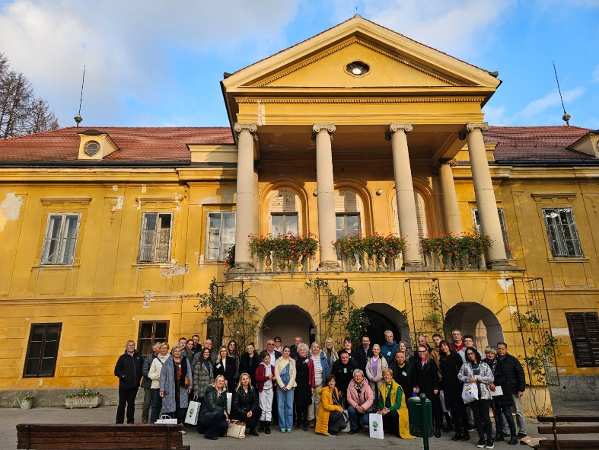

The Conference concluded with a panel discussion involving experts and representatives of the public sector and local authorities, who reflected on the presented topics, discussed the importance of preserving and valorizing cultural landscapes, and highlighted opportunities for future cooperation and joint initiatives within EU-funded projects.
In addition to the joint Conference activities, each project partner organized a multiplier event in their respective country in accordance with the project objectives and dissemination plan. The events aimed to present the project results and key topics related to the EU Cultural Landscape to a wider audience, including local stakeholders and community representatives.
The multiplier events were adapted to the local context, encouraged active participation and contributed to the visibility and impact of the project, while strengthening cooperation between partners and local communities and supporting future joint initiatives.
Udruženje Slovenaca Triglav, Bosnia and Herzegovina
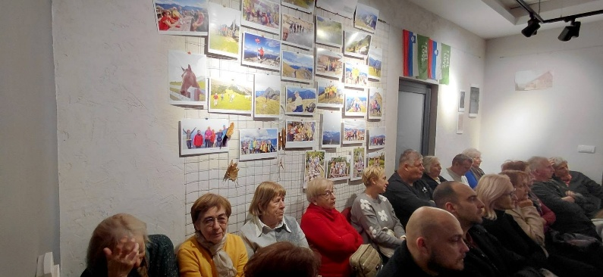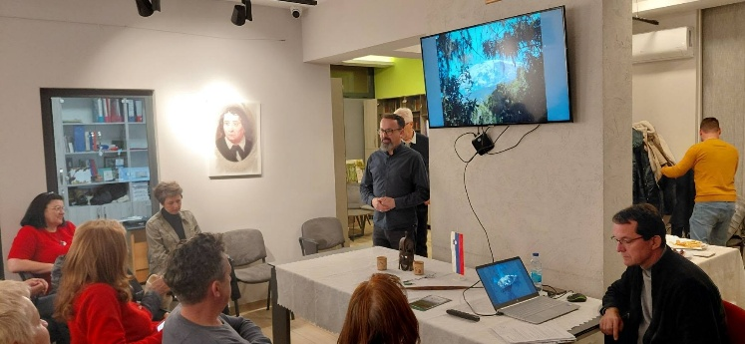

Obshtina Strumyani, Bulgaria
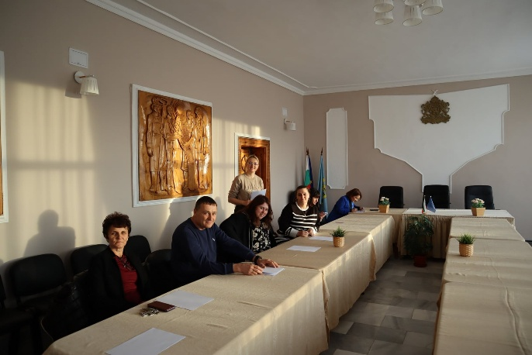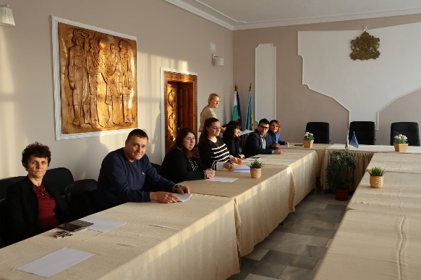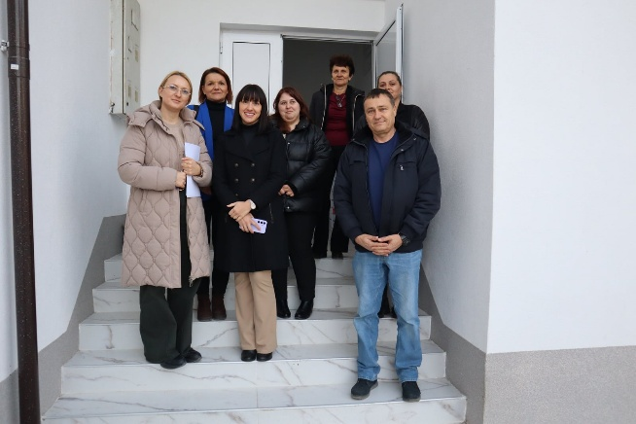

Comune di Soriano nel Cimino, Italy
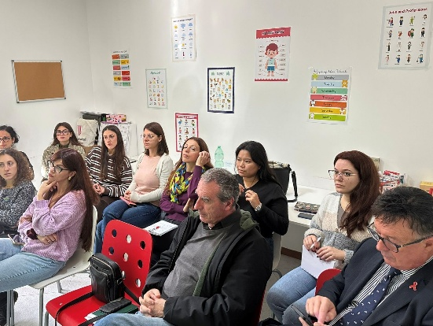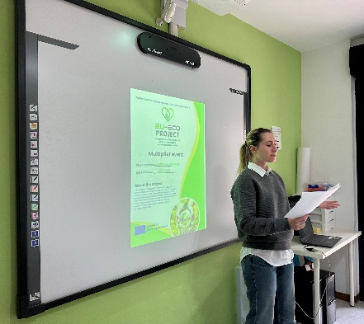

Sopronkovesd Kozsegi Onkormanyzat, Hungary
Razvojna agencija Sotla, Slovenia
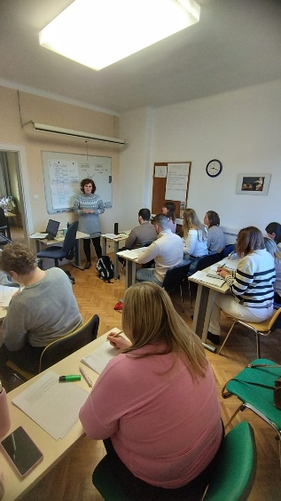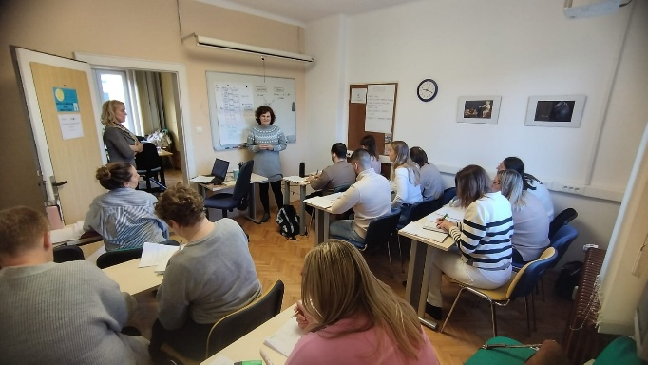

Danube 1245, Serbia
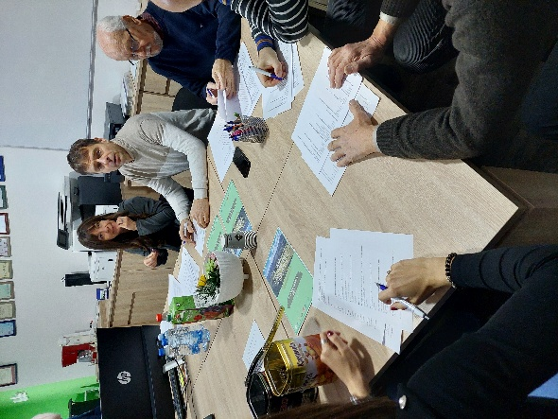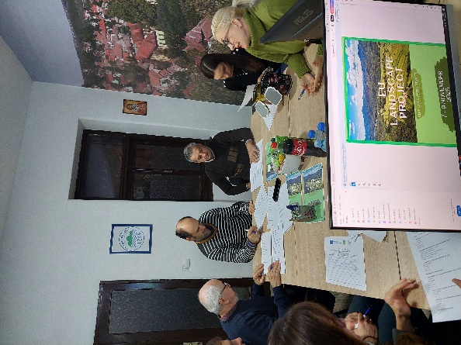
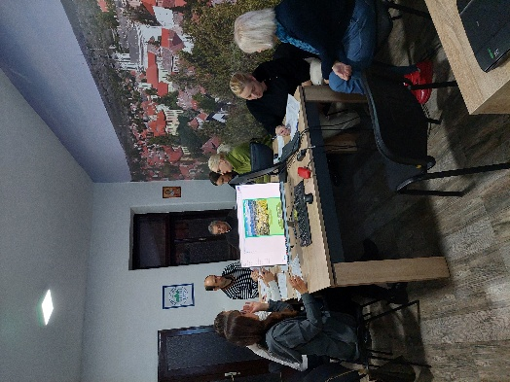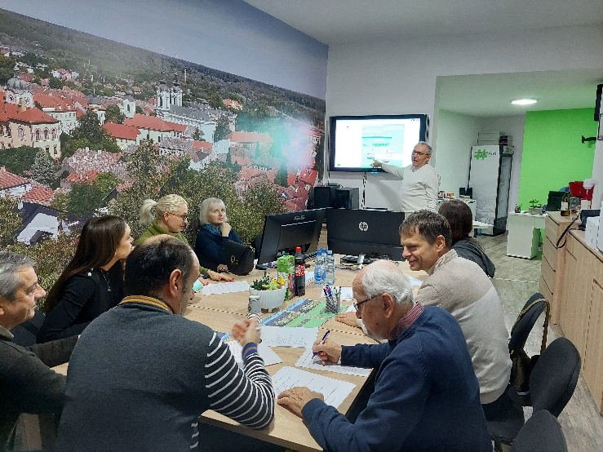
Furthermore, a project questionnaire was prepared and completed by all partners, providing structured feedback on the implemented activities and contributing to the evaluation of project outcomes and future cooperation possibilities.
Based on the completed questionnaires, project partners expressed a high level of satisfaction with the overall implementation of the project, particularly highlighting the organization of activities, the quality of workshops, and opportunities for cooperation and exchange of experiences. The feedback indicates that the project largely met its objectives and contributed to the promotion and preservation of the cultural landscape within the LAG PRIZAG area, while also showing strong interest in future cooperation and similar initiatives.
Each partner, including city of Novi Marof and Municipality of Breznički Hum where project was held, published report on their websites:
LAG PRIZAG, Croatia:
https://www.lag-prizag.hr/category/eu-krajobraz/
City Novi Marof, Croatia:
https://www.novi-marof.hr/izvjesce-projekta-eu-kulturni-krajobraz-odrzanog-na-podrucju-novog-marofa-i-breznickog-huma/
Municipality Breznički Hum:
https://www.breznicki-hum.hr/index.php/component/content/article/172-eu-kulturni-krajobraz/815-yet-mladi-koji-prihvacaju-zajednistvo-2?Itemid=437
Udruženje Slovenaca Triglav, Bosnia and Herzegovina:
https://udruzenjetriglav.com/sr/obavjestenja/1346-konacan-izvjestaj-o-projektu-eu-pejzazi
Obshtina Strumyani, Bulgaria:
https://www.strumyani.org/subsection-412-content.html
Comune di Soriano nel Cimino, Italy
https://comune.sorianonelcimino.vt.it/eu-cultural-landscape-project-held-in-novi-marof-and-breznicki-hum-in-croatia-7-9-november-2025/
https://www.facebook.com/story.php?story_fbid=1323579979799639&id=100064429490339&rdid=wHRhXmU2XuYw1mxX#
Sopronkovesd Kozsegi Onkormanyzat, Hungary:
http://www.sopronkovesd.hu/onkormanyzat/Palyazatok/EU_cultural_landscape_CERV.html
Razvojna agencija Sotla, Slovenia:
https://www.ra-sotla.si/projekt-eu-cultural-landscape-v-novem-marofu-and-breznickem-humu-na-hrvaskem-7-9-november-2025/
Danube 1245, Serbia:
https://www.dunav1245.org/2026/01/22/odrzan-projekat-eu-landscape/
https://www.facebook.com/dunav1245/posts/pfbid027ujso5fdrGx4LGpdkjBRrmZv4XvyDhT5MyJEo6y9sEcQqYRDYZWL6zpBCnhgguqal?rdid=eRYGccASbLGox2b4#
https://www.instagram.com/p/DTzuqJaDIHD/?igsh=ZTJwc2FlaXM5Yms3

Finally, five project participants were interviewed, and the interviews were recorded and published online. The links to the YouTube videos are provided below.
https://www.youtube.com/shorts/Ni1dnwrYF-k
https://www.youtube.com/shorts/iYIKUKxnerQ
https://www.youtube.com/shorts/5OLNkURVd9g
https://www.youtube.com/shorts/RcSBXGdlaBU
https://www.youtube.com/shorts/wLSpa2N7HE0

HISTORY OF CHANGES
VERSION | PUBLICATION DATE | CHANGE
1.0 | 01.04.2022 | Initial version (new MFF).

