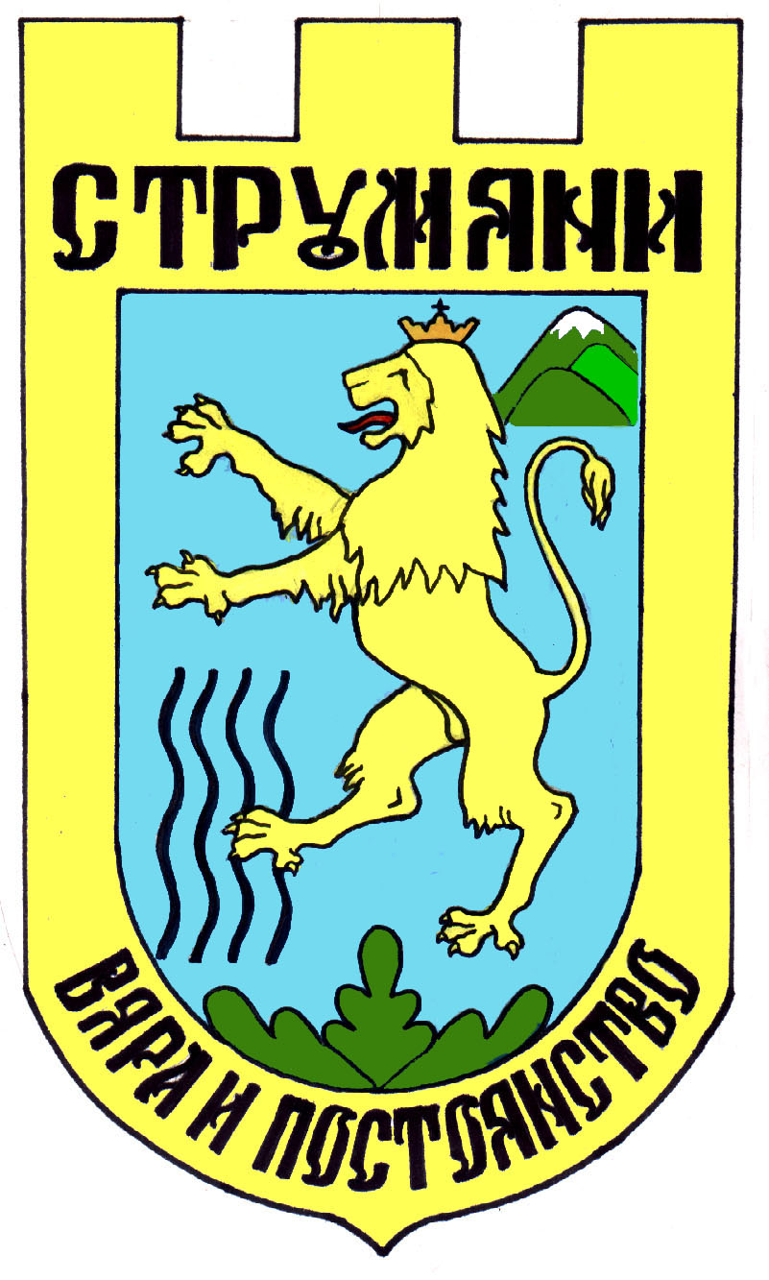
О Б Щ И Н А С Т Р У М Я Н И

Област Благоевград; тел./факс: 07434/31 05, тел: 31-08, www.strumyani.org, е-mail: strumyani_oba@yahoo.com
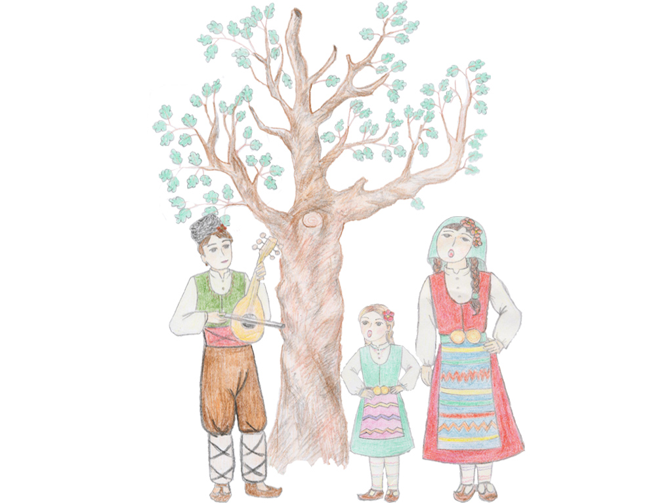
“MALESHEVO SINGS AND DANCES 2022”

7, 8 and 9 October 2022
Mikrevo village, Strumyani Municipality,
Bulgaria

SPECIAL CONDITIONS
FOR PARTICIPATION IN THE FESTIVAL

Application forms for participation in the Festival will be accepted
till 09.09.2022!

The Organizers of the Festival provide:

1.Preferential rates for accommodation of participants in the Festival on BB
basis /bed and breakfast/ or HB basis /bed, breakfast and dinner/ for one,
two or three overnights in hotels, located in the world famous balneo and
spa resort Sandanski town, known with its curative soft climate, clean fresh
air and hot mineral springs.
2.Support for providing transportation services /if needed/ from Sofia Airport
to the hotel and back and to the Festival place.
3.Prizes for the winners in Festival /diplomas and statuettes/.
4.A Diploma for each group.
5.”Welcome” reception for the leaders of the folklore groups from the Mayor
of Strumyani Municipality.
6.Advertising activities for promoting the Festival /newspapers, radio,
Television, flyers, posters and many others/.
7.Available ambulances and security services /if needed/ .

8. International Folklore Festival “Maleshevo sings and dances” will be held under conditions of prevention against Covid-19 keeping all instructions and orders given by the Ministry of health in Bulgaria.

9. Organizers of the Festival keep the right to change the program or to cancel the IFF “Maleshevo sings and dances”-2022 if the pandemic situation is getting worst or the official health authorities give instructions or orders to limit or to cancel public events.

The Participants in the Festival have responsibilities, as follow:

1.Personal responsibility of all participants for their health insurances
covering all needs of medical assistance and manipulations /if occured/.
2.Participation fee for the Festival is not required.
3.If hotel accommodation for participants is needed , in preferential prices in
the recommended Festival hotels , the group leaders are responsible for the
payments of all costs for lodging and board of the group.

4.Group leaders are responsible to send reservation request to the hotels for
accommodation of the group with the information as follow: period of
staying, number of overnights, number and type of rooms, board /BB or
HB/, rooming list with the names of the guests and they are also responsible
to arrange the bill directly to the hoteliers.

5.Recommended hotels for the Festival’s participants:

№ | Hotel name | Contacts
1 | Hotel Timeout***  Sandanski town | info@hoteltimeout.com  Georgi Manolev  Tel: +359746/35121  Fax: +359746/30971  Моb: +359898/734323
2 | Hotel AVIS***  Sandanski town | hotelavis@abv.bg  Mob:00359 885 40 55 20
3 | Hotel PANORAMA***  Sandanski town | marketing@panorama-bg.com  Моb: +359 898 63 57 01 /Reception/  Моb.: +359 892 25 43 66 /Marketing department/
4 | Hotel ANELI**  Sandanski town | office@hotelaneli.com  Tsvetelina Manoilova  Моb.: +359 885 860 505;  +359 888 434 333; Tel.:+359 746/318 44
5 | SPA Hotel Spartak***  Sandanski town | hotelstnikolas@abv.bg  Karamfilka Hristova  Mob:00359 887 444 888
6 | Interhotel SANDANSKI****  Sandanski town | marketing@ihsand.com  Теl.: +359 746 31136  Моb.: +359 886 978786
7 | Hotel MEDITE***  Sandanski town | mаrketing@hotelmedite.com  Теl.: +359 888 36 36 67
8 | Hotel Pautalia***  Sandanski town | info@hotel-pautalia.com  0879 998 500  0746 3 26 33
9 | Motel Karelia  Strumyani village,  Strumyani Municipality | kareliastrum@mail.bg  Phone:00359 7434/59 41  Mrs.Sofia
10 | Motel Thessaloniki  Strumyani village,  Strumyani Municipality | Mob:00359 888 990626  Mr.Delcho Georgiev
11 | Blagovesta Guesthouse *  Ilindenci village,  Strumyani Municipality | blagovestaguesthouse@abv.bg  Mob:00359 888 438 208  Mrs.Koteva
12 | Hotel Brioni ***  Kresna town | perun_2006@abv.bg  Mob: 00359 885 626017; 00359 7433 2224
13 | Hotel Colosseo***  Sandanski town | Colosseo.bg@gmail.com  Mob: 00359 885 707330  Mr. Kiril Vezarov
14 | Eco village “Under The Cliffs” – Ilindenci, Bulgaria | Village.ilindenci@gmail.com  Mob: 00359 888 854311; 00359 988 334399;  00359 887 932 488  Ilia Kutlev
15 | Hotel Perun ***  Sandanski town | hotel@hotel-perun.com  Mob: 00359 893 630263
16 | Hotel Astra ***  Sandanski town | Astra_hotel@mail.bg  Mob: 00359 746 31065;
17 | Hotel Elit ***  Sandanski town | Dukov100@abv.bg  Mob: 00359 883 505040  Mr. Dukov
18 | Hotel Andoni **  Sandanski town | Hotel_andoni@abv.bg  Mob: 00359 746 31056
19 | Hotel Kartalovec **  Sandanski town | Mob: 00359 887 599057  Mrs. Elena Polimerova  Mob: 00359 898 203061  Mr. Adjev
20 | Spa hotel Sveti Vrach *** Sandanski town | Mob: 00359 887 599057  Mrs. Elena Polimerova

6.It is necessary each folklore group to provide a flag of its own country and a Flag man who should participate in the official Opening ceremony of the Festival.

7.For contacts:

Strumyani Municipality
Blagoevgrad region,Bulgaria
Strumyani village 2825
Square “7th April” № 1

Telephone: + 359 07434/ 31-08
Fax: +359 07434 / 31-05
Mrs.Miglena Koteva-Dimitrova-main coordinator of the Festival

Mob: + 359 878 42 81 88 ;+ 359 878 428 363
E-mail: maleshevopee@gmail.com, strumyani_oba@yahoo.com;
Web: www.strumyani.org
Web:www.strumyani.eu

