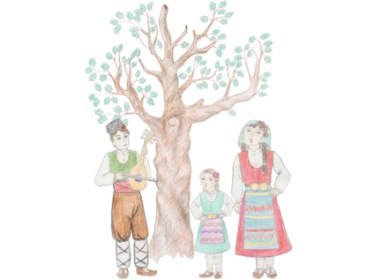
APPLICATION FORM
FOR PARTICIPATION
IN XVI-th INTERNATIONAL FOLKLORE FESTIVAL
“MALESHEVO SINGS AND DANCES”-2019
Mikrevo village
4, 5 and 6 October 2019

The full title of the ensemble / The name of the individual performer:
………………………………...……………………………………………………………………………………………………………
From ……………………………………………………………………...……………………………………………………………..
Region…………………………..………… Municipality…………………..……………………………………………………..
Town/Village…………………………………….. Postal code ………………., Street ……………………………… ……………………..…, № ……………., telephone/mobile ……………………….............................................................
E-mail: …………………………………………………………………………………………………………………………………..
Artistic manager: …………………………………………………………………………………………………………………...
Contact person: ………………………………................Telephone………………………............................................ Number of participants: ……………………………………………………..
Age of the participants:
□ younger than 12 years old;
□ younger than 18 years old;
□ older than 18 years old.
Category in which they compete:
□ Traditional folklore;
□ Revised folklore.
We would like to participate on ………………………………. 2019 from …………………………hour.

Titles/names of the individual performances and performers:
1.……………………………………………………………………………………………………………………………………………
2.……………………………………………………………………………………………………………………………………………
3…………………………………………………………………………………………………………………………………………….

Duration of the whole performance: ………………… ………………………………………………..……./minutes/

According to the Regulations, Time limits for the performances are:
-ensembles, performing folklore songs and dances /up to 20 minutes/;
-folklore dancing ensembles /up to 15 minutes/;
-dancing clubs and schools for traditional Bulgarian dances /up to 8
minutes/;
- vocal groups and choirs, performing folklore songs /up to 6 minutes/;
- instrumental groups, performing folklore music/up to 6 minutes/;
- individual performers, duets and trios/up to 5 minutes/;
- instrumental performers/up to 5 minutes/;
- narrators and rituals /up to 6 minutes/.
The evaluation committee has right to stop the performance, if it is longer than the set Time limits.

Deadline for sending Application forms is till 05.09.2019 on the following address:
Strumyani Municipality,Strumyani village 2825
1,”7th April Square”
Region of Blagoevgrad, Bulgaria
or by e-mail: maleshevopee@gmail.com; strumyani_oba@yahoo.com
Contacts:
Fax 00359 7434 3105, Telephone 00359 7434 3108
Mrs.Miglena Koteva-Dimitrova -Chief coordinator – mob:00359 878 42 81 88 ,
Mob.00359 878 428363, Web: www.strumyani.org

